Assignment 18

**Task 1. Create a new Power BI report. Load the worksheets from the workbook in the above folder, and use them to create a data model.**

Step 1. Create connections in data model and In events table set Event Date data type to date field.

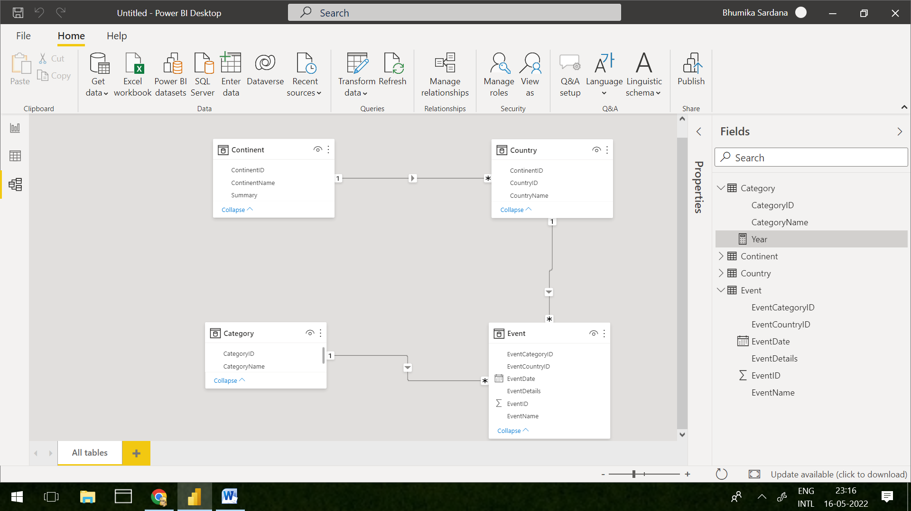

Step 2. Add Table and Matrix Visualization and add following columns in respective field.

Values->ContinentName(Table)

Row->EventDate->Year(Matrix)

Column->CountryName(Matrix)

Values->Event ID(Matrix)

